Resume Handout
A resume is a marketing tool that promotes, advertises, and introduces you as a candidate for a job. It is a record of your education, work, and other experiences that encourages an employer to want to hire you.

Formatting a Resume:
- Your resume should be no more than one page.
- A resume should be easy to read and navigate.
- You should separate different experiences/work into different sections.
- White space is a good thing (you don’t want to clutter your resume).
- Your font should be easy to read (such as Times New Roman) and an appropriate size (10 or 12).
- Your resume should be consistent in its formatting (for example, use bold all the time – not just once – for headers and keep everything lined up neatly).
Resume Language:
- You should be as clear and concise as possible.
- You should sound professional and use words that are appropriate to that context (nothing colloquial or slang-y).
- You should use strong action verbs at the beginning of each bullet point.
- You should be specific and give concrete examples of the skills you say you have.
- Your language should be results-oriented; you should show specific numbers and show that something was achieved and not just your daily duties at that job.
General Resume Tips:
- A resume is a living document and should be updated regularly.
- You do not need to include all of your experiences in your resume.
- You should make your resume job-specific and adjust it to fit the requirements of each job to which you are applying.
- There are many different types of resumes, but one of the most common and easiest to follow is a chronological structure.
- Double check your resume for any errors in spelling, punctuation, and grammar and have someone else (like the Writing Center) also go over it.

Common Sections of a Resume
Education:
- Names and dates for the colleges you have attended
- Degree or expected degree
- Majors, minors, concentrations
- Optional information includes:
  - GPA (if it is higher than 3.0 on a 4.0 scale)
  - Study Abroad
  - Relevant Coursework
  - Academic Awards/Honors
Work:
- Name of the organization or company
- Your job title
- Location (city/state/country) of the job
- Dates you worked for that job
- Bullet pointed list of your accomplishments at that job
Volunteering:
- Name of the organization
- Your role/title
- Location (city/state/country) of the job
- Bullet pointed list of the skills you gained from that experience
Honors/Awards/Achievements:
- Include the date/duration of the honor/award/achievement
- Any academic or professional awards you have received
- Scholarships

Skills:
- Only list skills that are testable and concrete (if asked, you could prove that you are good at a particular skill)
- Technology-related skills (ex. Knowledge of Microsoft Office)
- Languages (ex. Proficient knowledge of Spanish)

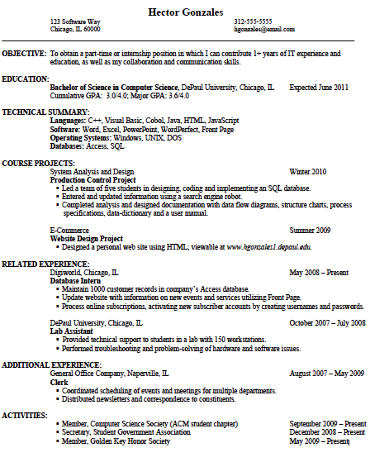
Highlights clear relevant experience
Utilizes numbers to maintain specificity
Efficient use of white space
Effective use of action verbs
Specific objective pertaining directly to the position.

Action Verbs

Each bulleted point on your resume should begin with an action verb that shows your achievements and skills. It is a good idea to vary the verbs you use on your resume. Here is a list of some action verbs that you could include.

A Constructed Established
Achieved Consulted Estimated
Acted Contrasted Evaluated
Adapted Controlled Examined
Adjusted Converted Executed
Administered Convinced Expanded
Advanced Coordinated Expedited
Advised Counseled F
Altered Counted Facilitated
Analyzed Created Filed
Appraised Cultivated Filled
Arranged D Forecasted
Assembled Decided Formulated
Assessed Decreased Fostered
Audited Defined Fulfilled
B Delivered G
Balanced Demonstrated Gained
Budgeted Designed Gathered
Built Detected Generated
C Determined Grew
Calculated Developed Guided
Calibrated Devised H
Categorized Diagnosed Handled
Charted Differentiated Headed
Classified Distributed Hired
Coached Documented I
Collected Doubled Identified
Combined Drafted Illustrated
Communicated E Implemented
Compiled Edited Improved
Composed Eliminated Increased
Computed Encouraged Influenced
Conducted Engineered Informed
Configured Enhanced Initiated
Consolidated Ensured Inspected

Installed Posted Set up
Instituted Prepared Simplified
Instructed Prescribed Sold
Integrated Presented Solved
Investigated Priced Specified
Interviewed Processed Started
Invented Produced Strategized
Intended Promoted Streamlined
L Protected Studied
Launched Provided Summarized
Lectured Purchased Supervised
Led R Supplied
Liaised Realized Supported
Logged Received T
M Recommended Tested
Maintained Reconciled Tracked
Managed Recorded Trained
Manufactured Recruited Transformed
Marketed Redesigned Translated
Measured Reduced Troubleshot
Mediated Referred U
Mentored Removed Updated
Migrated Reorganized Upgraded
Minimized Repaired V
Monitored Reported Verified
Motivated Represented W
N Researched Weighted
Negotiated Resolved Wired
O Restructured Won
Obtained Revamped
Operated Reviewed
Orchestrated Revised
Ordered Revitalized
Organized Routed
Originated S
Oversaw Scheduled
P Selected
Performed Separated
Persuaded Served
Planned Serviced

From http://careercenter.depaul.edu/_documents/resume_packet.pdf
From http://careercenter.depaul.edu/_documents/resume_packet.pdf

