“How Do I Cite This?” APA Handout

What to Cite

- Quotations, paraphrases, and summaries of an outside source
- Ideas from another source
- Little-known or arguable claims
- Images, videos, or music
- Graphs, tables, and other statistical information from a source
- Experiments, surveys, and interviews conducted by others
- Lecture notes

Incorporating Quotes, Paraphrases, and Summaries

General Guidelines
- Introduce the quote, paraphrase, or summary so that it connects to your ideas and lets us know where it comes from.
- Some common verbs used to introduce quotes, paraphrases or summaries include: claimed, wrote, argued, contended, noted, stated, and found (note that APA uses the past tense).
- Provide an in-text citation at the end of the sentence. (NOTE: The citation goes at the end of the sentence and not necessarily at the end of the quote.)

Quoting: Uses the exact words from another source and should include quotation marks around the passage. You can use brackets [ ] and ellipses … to show modifications.

Example introducing the author(s): Bilingual education theorist Lily Wong Fillmore (2004) argued, “In a society that is as diverse in linguistic, cultural, and national origins as the USA, it is inevitable that language would eventually become a source of conflict in education” (p. 340).

Example without introducing the author and showing bracket modification of original capitalization: The reality we found is that, “[i]n a society that is as diverse in linguistic, cultural, and national origins as the USA, it is inevitable that language would eventually become a source of conflict in education,” as indeed it has (Fillmore, 2004, p. 340).

Paraphrasing: States ideas from an original source but not the author’s original words and does not need quotation marks around the whole passage.

Keep in mind the following when writing your paraphrase:
- Keep the author’s main ideas; don’t stray from the main point
- Use your own words
- Use your own sentence structure
- Include specially memorable language in quotation marks
- Keep your comments, notes, and explanations separate

Example: Language within education is a contentious subject because of the level of diversity within the United States (Fillmore, 2004, p. 340).

Summarizing: States the main point or main idea from an original source but not specific details and does not need quotation marks

In-text Citations

There are three pieces of information that you need for APA in-text citation: the author’s last name, the year the source was published, and the page number. The in-text citation can be formatted two ways:

According to Inozu (2011), “In the context of foreign language learning, research in the last three decades suggests that learner beliefs have the potential to influence both their experiences and actions” (p. 645).

Attitudes toward learning a foreign language can affect how a student begins to understand it (Inozu, 2011, p. 645).

Of course, sometimes citations are not this straightforward. If there are multiple authors or no author or no page numbers, etc., please see one of our resources listed at the end of the handout for additional information.

Formatting

Title Page

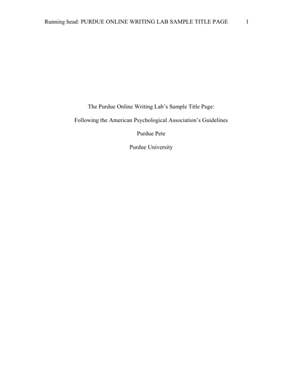
In the center of the page, include the following information:
The title of your paper
Your name
Your school
In the upper left hand corner, include “Running head: YOUR TITLE IN CAPS.” Remember, “Running head” is only listed on the title page. For the rest of your paper, just include “YOUR TITLE IN CAPS.”
In the upper right hand corner, include the page number.
(Angeli et al., 2010)

References
(This is what the bibliographic citations at the end of your paper are called in APA)

Book
Author’s name (Last, first initials)
Title of book (italicized)
City of publication

Myers, D.G. (2004). Psychology (7th ed.). New York: Worth Publishers.

Publisher
Edition (in parentheses)
Date of publication (in parentheses)

Article from a Database
Title of journal (italicized)
Name of article (no quotes or italics and only the first word is capitalized)

Inozu, J. (2011). Beliefs about foreign language learning among students training to
teach English as a foreign language. Social Behavior and Personality, 39(5),
645-654. Retrieved from EBSCOhost Database.
Issue number
Page numbers of article
The database you used (preceded by “Retrieved from”)
Volume number

Online Article
Title of article (no quotes or italics)
Name of website (in italics)

Gardner, A. (2012, August 29). Chocolate may lower men’s stroke risk. Health.
Retrieved from
http://news.health.com/2012/08/29/chocolate-men-stroke
risk/
Link to the article (preceded by “Retrieved from”)

Things to Watch Out For

- Is your quote really long?
- Does the source have multiple authors?
- Is the passage you want to use from someone other than the author?
- Do you need to leave out a portion of the quote?
- Do you need to add a word or two to the quote in order for it to make sense?

If you’re ever unsure, use the following resources for help:

- Your instructor (check your syllabus for contact information including email and office hours)
- The Writing Center
  - Loop: 1600 Lewis Center, (312)362-6726
  - Lincoln Park: 250 McGaw Hall, (773)325-4272
- Publication Manual of the American Psychological Association, Sixth Edition
  - Available at the Writing Center or library
- St. Martin’s Handbook
  - Available at the Writing Center or library
- Purdue OWL: https://owl.english.purdue.edu/owl/resource/560/01/
- Diana Hacker: http://bcs.bedfordstmartins.com/resdoc5e/RES5e_ch09_s1-0001.html

References

Angeli, E., Wagner, J., Lawrick, E., Moore, K., Anderson, M., Soderlund, L., & Brizee,
A. (2010, May 5). General format. Retrieved from
http://owl.english.purdue.edu/owl/resource/560/01/
Fillmore, L.W. (2004). Language in education. In E. Finegan & J.R. Rickford (Eds.),
Language in the USA (339-360). Cambridge: Cambridge UP.
Inozu, J. (2011). Beliefs about foreign language learning among students training to
teach English as a foreign language. Social Behavior & Personality: An
International Journal, 39(5), 645-653. Retrieved from EBSCOhost Database.

