“How Do I Cite This?” MLA Handout

What to Cite

- Quotations, paraphrases, and summaries of an outside source
- Ideas from another source
- Little-known or arguable claims
- Images, videos, or music
- Graphs, tables, and other statistical information from a source
- Experiments, surveys, and interviews conducted by others
- Lecture notes

Incorporating Quotes, Paraphrases, and Summaries

General Guidelines
- Introduce the quote, paraphrase, or summary so that it connects to your ideas and lets us know where it comes from.
- Some common verbs used to introduce quotes, paraphrases or summaries include: claims, writes, argues, contends, notes, states, and finds (note that MLA uses the present tense).
- Provide an in-text citation at the end of the sentence. (NOTE: The citation goes at the end of the sentence and not necessarily at the end of the quote.)

Quoting: Uses the exact words from another source and include quotation marks around the passage. You can use brackets [ ] and ellipses … to show modifications.

Example introducing the author(s): Bilingual education theorist Lily Wong Fillmore argues, “In a society that is as diverse in linguistic, cultural, and national origins as the USA, it is inevitable that language would eventually become a source of conflict in education” (340).

Example without introducing the author and showing bracket modification of original capital letter: The reality we find is that, “[i]n a society that is as diverse in linguistic, cultural, and national origins as the USA, it is inevitable that language would eventually become a source of conflict in education,” as indeed it has (Fillmore 340).

Paraphrasing: States ideas from an original source but not the author’s original words and does not need quotation marks around the whole passage.

Keep in mind the following:
- Keep the author’s main ideas; don’t stray from the main point
- Use your own words
- Use your own sentence structure
- Include specially memorable language in quotation marks
- Keep your comments, notes, and explanations separate

Example: Language within education is a contentious subject because of the level of diversity within the United States (Fillmore 340).

Summarizing: States the main point or main idea from an original source but not specific details and does not need quotation marks

In-Text Citation

At the end of your sentence in parentheses should be the author’s last name and page number. The period will go after the citation. The in-text citation can be formatted two ways:

In his article about learning foreign languages, Inozu states, “In the context of foreign language learning, research in the last three decades suggests that learner beliefs have the potential to influence both their experiences and actions” (645).

Attitudes toward learning a foreign language can affect how a student begins to understand it (Inozu 645).

Of course, sometimes citations are not this straightforward. If there are multiple authors or no author or no page numbers, etc., please see one of our resources listed at the end of the handout for additional information.

Formatting
In the upper right hand corner, include your last name with the page number.
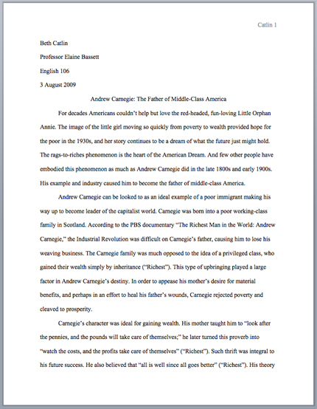
In the upper left hand corner, include the following information:
Your Name
Your Instructor’s Name
Your Class
The Date (day/month/year)
(Russell, Brizee, and Angeli)

Works Cited
(This is what the bibliographic citations at the end of your paper are called in MLA)

Book
Year of publication
Author (Last name, first name)
City of publication

Lahiri, Jhumpa. The Namesake. Boston: Houghton Mifflin Company, 2003. Print.

Medium of publication
Publisher
Title of book (italicized)

Work in an Anthology
Title of anthology (italicized)
Title of short story (in quotes)

Steinbeck, John. “The Chrysanthemums.” Literature: An Introduction to Fiction,
Poetry, Drama and Writing. 11th ed. Ed. X.J. Kennedy and Dana Gioia. New
York: Longman, 2010. 226-33. Print.
Editors (First name, last name)
Edition

Journal Article from a Database
Name of journal (italicized)
Name of article (in quotes)

Totaro, Rebecca. “Securing sleep in Hamlet.” Studies in English Literature, 1500-1900
50.2 (2010): 407. Literature Resource Center. Web. 29 Aug. 2013.
Date you found the article
Issue number
Volume number
Year of publication (in parentheses)
Page numbers of article
Name of database (italicized)

Online Newspaper or Magazine Article
Name of article (in quotes)
Name of newspaper or magazine (in italics)

Perez-Pena, Richard. “Smoothing the Path From Foreign Lips to American Ears.” The
New York Times. The New York Times Company, 28 Aug. 2012. Web. 29 Aug.
2013.
Date you found the article
Date of publication
Publisher

Web Site
Name of website (italicized)
Name of specific page (in quotes)

“Hourly News Summary.” National Public Radio. Natl. Public Radio, 20 July 2007.
Web. 20 Sept. 2013.
Date of publication
Publisher

Things to Watch Out For
- Is your quote really long?
- Does the source have multiple authors?
- Is the passage you want to use from someone other than the author?
- Do you need to leave out a portion of the quote?
- Do you need to add a word or two to the quote in order for it to make sense?

If you’re ever unsure, use the following resources for help:

- Your instructor (check your syllabus for contact information including email and office hours)
- The Writing Center
  - Loop: 1600 Lewis Center, (312)362-6726
  - Lincoln Park: 250 McGaw Hall, (773)325-4272
- MLA Handbook for Writers of Research Papers, Seventh Edition
  - Available in the Writing Center and library
- St. Martin’s Handbook
  - Available in the Writing Center and library
- Purdue OWL: https://owl.english.purdue.edu/resource/747/01/
- Diana Hacker: http://bcs.bedfordstmartins.com/resdoc5e/RES5e_ch08_s1-0001.html

Works Cited

Fillmore, Lily Wong. “Language in Education.” Language in the USA. Ed. Edward
Finegan and John R. Rickford. Cambridge: Cambridge UP, 2004. 339-360. Print.
Inozu, Julide. “Beliefs About Foreign Language Learning Among Students Training to
Teach English As A Foreign Language.” Social Behavior & Personality: An
International Journal 39.5 (2011): 645-653. Academic Search Complete. Web. 4 Oct. 2013.
Russell, Tony, Allen Brizee, and Elizabeth Angeli. "MLA Formatting and Style Guide."
The Purdue OWL. Purdue U Writing Lab, 4 Apr. 2010. Web. 29 Sept. 2013.

