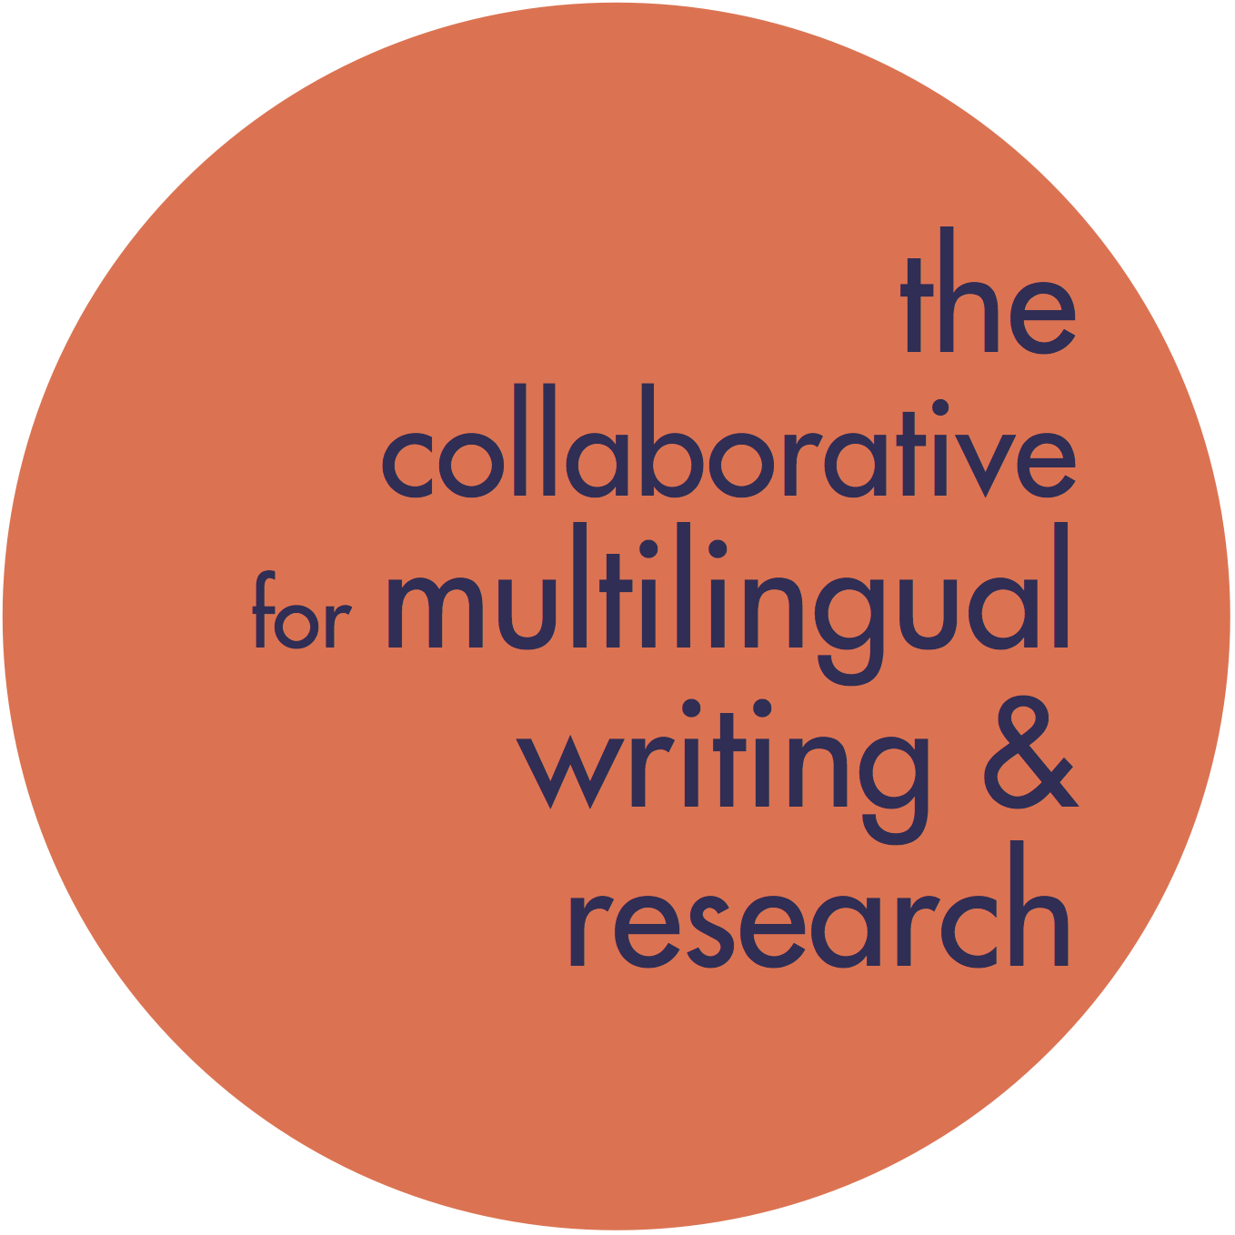
Unpacking Agenda Setting in CPAs: Quick Guide

Set the Stage:
- Useful things to learn at the start of an appointment:
  - Where is your partner from and how many languages does he/she speak?
  - How many years has he/she been learning English?
  - How did your partner learn English? In a classroom or another context?
  - Has your partner faced any challenges in adapting to an English-speaking environment?
  - Does your partner have certain expectations/ideas for the CPA based on previous experiences?
- Take time to explore options with your partner (adjusting based on their familiarity with these options from previous appointments). Let them know that you are going to explain several options and ask a few questions to help find a good focus for your conversation, and that you’ll both take notes as part of the process.

Agenda Setting Breakdown

Options | Overview | Strategy
Practicing Conversation | - Pick an interesting topic.  - Learn more about one another. | - Have the student pause to write down two topics they are interested in discussing; you do the same.
Talking about Conversation | - Examine the rules for different conversational contexts. | - Have your partner think about and write down some of the contexts where he/she needs to interact in English (you do the same, to model and suggest).  - Compare notes and ask what differences they notice and whether one context is more challenging for them than another.
Talking about language | - Examine things like idioms, slang, or grammar more closely. | - Have the student think about and write down a few words or phrases they’ve recently learned/encountered in conversation or perhaps on a television show that they have questions about – jot down a few you think might be useful to learn.  - Ask if there is a particular grammatical element (such as a verb tense, adverbs vs. adjectives, nominals etc.) that the student would like to practice or discuss.
Feedback on Grammar | - Find out what your partner is looking for from you in response to their contributions to the conversation | - Does your partner want you to identify errors for them during the conversation and to what extent?

Best Practices for Successful CPAs

  - Be sensitive to how your partner feels about speaking English; some writers feel very insecure about their language skills.

  - Your genuine interest will have a strong influence on the conversation. “Conversation for conversation’s sake tends to fall flat and sound contrived” (Dooley 501). Be prepared for the fact that good conversations require focus and a level of effort.

  - Make sure there’s an exchange. Pay attention to how much you’re talking; while your partner does benefit from hearing how you structure language, the goal is for your partner to practice shaping and structuring language in return – this is key to helping them master language for both oral and written activities.

  - Be prepared for longer silences as your partner organizes his or her ideas. It can be tempting to fill silences by talking, but consider that your partner is sorting through a lot of grammatical, syntactical, and phonological choices as they respond.

  - If the writer you are working with seems confused by something you have said, try repeating the utterance but phrasing it differently. For example:
      - What are some of your favorite hobbies? What do you do for fun in your free time? For example, what do you like to do on the weekends?
      - Here, the more unusual word “hobbies” gets replaced with “fun” and “free time,” but the student may still be confused, and adding the context of the weekend may clarify your meaning.

  - Pay attention to your own language and vocabulary; don’t dumb down what you have to say, but be conscious of when your statement or a particular word might need clarification. Don’t be afraid to ask if the writer is familiar with a certain word – this can be a good learning opportunity.

  - When it comes to grammar, don’t just correct, work to model and explain the usage.
      - For example, if a writer says, “Yesterday I go to the store,” don’t simply tell the writer that “went” is the correct verb conjugation here. Instead, point out that yesterday is a moment in the past, and because the writer is talking about a past action, he or she should use the simple past tense, which is “went.” You might then talk also about the irregular conjugation of the verb go.
      - Don’t be afraid to look things up together as part of this process, or involve other tutors in the explanation.

  - Remember that you can use the Internet to research questions together or give a visual aid to your conversation.

  - Remember that it helps ELLs to both see and hear the language that they’re learning. Feel free to write new words down and incorporate written texts, online resources, and visuals to complement the appointment.
