It’s time to play…
Citation Creation!

Directions: In groups of 2-3, write a correctly formatted MLA style citation for each of the displayed sample sources.

Round 1

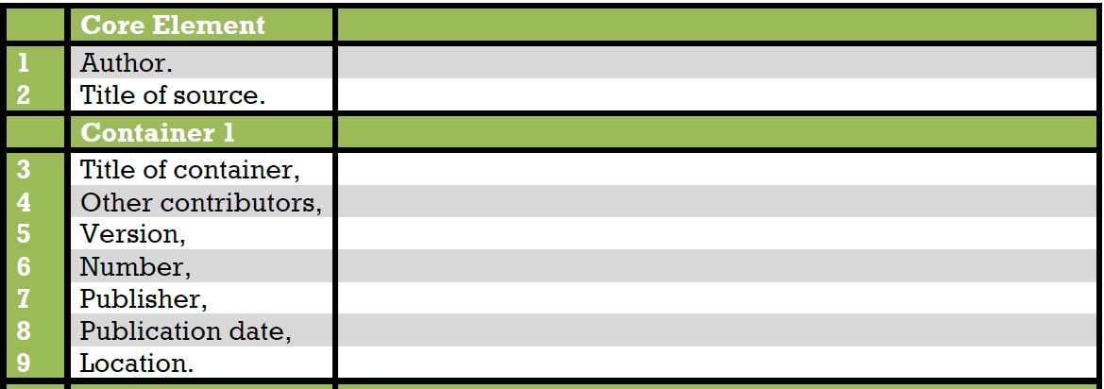

Works Cited:

Round 2

Works Cited:

